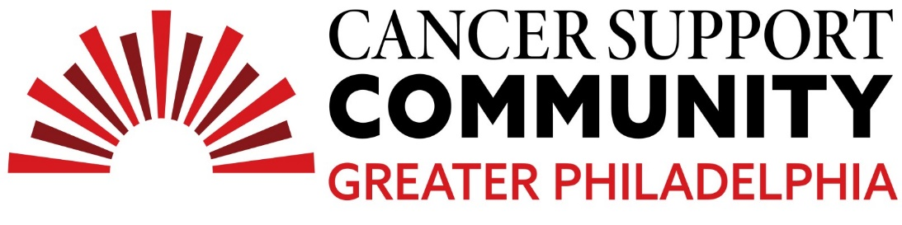
2024 Ben Straus High School Teen Essay Contest
Julian Nastasi
We’re All In This Together

A long time ago, my great-grandfather worked in the coal mines in West Virginia. As you can imagine, he later developed lung cancer and passed away. He was also a chain smoker, but back then they didn’t understand all the consequences of smoking or tobacco use. More recently, my great-grandmother passed away. During her life, she was diagnosed with breast cancer and she had horrible scars from her treatment. During her treatment, they didn’t have the technology and specialized equipment we have today. Thinking about it, both of them must have suffered without the advancements made since their diagnosis. Sadly, many hundreds of thousands have also suffered from this horrible disease.
None of us know if or when we’ll be diagnosed with cancer. But that’s the scariest thing about cancer; you don’t have to live a dangerous life to get a dangerous disease. Nonsmokers can get lung cancer. People who apply sunscreen every day can get skin cancer. Elite athletes can get bone cancer. Sometimes there are genetic markers that make cancer more likely, but many times there aren’t. I’m lucky that my parents don’t have cancer. But that doesn’t stop me from worrying about it. Then I came across this essay opportunity and that got me thinking.
Everyone watches TV. Everyone sees the commercials for different charities asking for donations. We see the sorrow and devastation of what cancer does not just to one’s own body and spirit, but also to one’s family. We all pray for positive outcomes for those patients and celebrate when we hear of those who are cured or in remission. But cancer is just one of the horrible debilitating diseases we face. I have had two great-grandmothers die from Chronic Obstructive Pulmonary Disease (COPD). I was young when they passed away, but I’ve heard over the years how hard it was to watch them struggle to breathe. My grandfather has been diagnosed with Parkinson’s Disease. I always visit him and I’m old enough that I've seen him decline with my own eyes. He used to take me on hikes in the woods and we’d play hide-and-seek in the backyard – now he can barely walk even after multiple surgeries and the assistance of a walker.
I have friends and extended family that have loved ones with cancer. I also have personal heroes of mine who have had cancer. My favorite drummer, Neil Peart, had brain cancer and unfortunately passed away on January 7, 2020. He will be remembered by many for his legendary drumming and songwriting for the band Rush. I still remember the day that he passed away. It was sad knowing one of the greatest musicians had left our world. Although all of the tributes people made online that day were nothing short of amazing. Many people work to raise money for cancer research after a loved one or hero passes away; as a way to honor them. But the more I think about it, the more I feel that we should all try to remember that everyone’s burden is equal and no loss is more or less important than another. Every day we go on social media and witness someone being discriminated against. It’s hard to watch the news and not to see murder and hate. It’s difficult to ignore how we are being divided by our political views, religion, or whatever else we choose to believe is different or wrong from what we think is right. But the truth is, we are all equal! It honestly perplexes me why we need to classify everyone and everything into categories. Why can’t we all love our differences? Writing this essay about cancer honestly reminds me of that. I have had loved ones die from cancer. But I have also had loved ones die from other horrible incurable diseases. Can’t we all be in this together? Can’t we all be there for one another regardless of what skin color we have, gender we are, country we were born in, etc.? Cancer and disease come for us all. I believe that if we stand united, we can overcome cancer and so much more.
Cancer is a huge fear for a lot of people, and that fear is completely understandable. But I believe cancer is beatable. I believe all the horrible diseases our world faces are preventable. I will not stop believing that there is hope for everyone as doctors and scientists are working around the clock to find cures for these devastating illnesses. They are discovering new therapies and making new developments that are creating new treatments for cancer and other debilitating diseases. I choose to believe that we’re all in this together. If we can continue to support each other mentally and emotionally, help raise awareness, continue to donate our time and money, and share findings and resources I’m convinced that within the near future, we will finally be able to say that cancer is something that we no longer have to fear.

