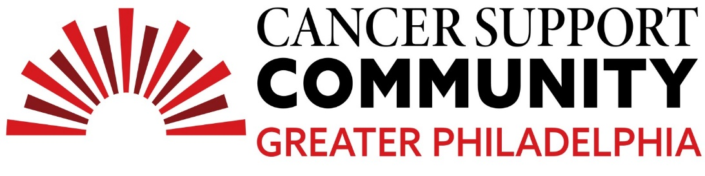
2024 Ben Straus High School Teen Essay Contest
3rd Place Winner
Madeline Swenson
A Woman Made of Steel

We have all thought about what if. What if this thing never happened to me… would I be where I am now? Would everything be the same? We often think about what could be or what could have been. Life, however, has its own way of playing out.

I often think about my what if. What if I never had cancer? Would I be who I am today? Whether I see the effects of cancer in my life as a blessing or a curse, it has significantly impacted my character today. I was first diagnosed with ALL (Acute Lymphoblastic Leukemia) when I was seven years old. I will admit, because I was young, I do not recall much. What I do know is that cancer very negatively impacted my childhood. I know this would be true for other victims of childhood cancer as well. I was forced to grow up fast. I had to know words like hemoglobin, spinal tap, chemotherapy, lymph nodes along with many more. By the time I was a year into treatment I was a pro at using this new vocabulary. These are things most eight year olds know nothing about. But growing up quickly made it hard for me to make friends. Kids my age did not know what these words meant. When I came to school rocking my new bald look they were confused when I blabbed words like chemotherapy and talked about my counts being low. Friends used to be a hard topic for me. I was too young to understand that my classmates did not know anything about cancer. It greatly impacted my life, so how was it that my peers did not know what it was? It was almost annoying that no one understood. However, this experience made me treasure the friends that stayed with me even when they didn’t understand my new found words or experience. My relationship with friends was just one of the ways cancer affected my life.

After two and a half years of chemotherapy we celebrated the end of treatment on my tenth birthday. I was cancer free for only about three years when I relapsed. This experience I can recall much more. I was in sixth grade when I was diagnosed. The second time around I would say it impacted me more. I was older and understood more. So again, I matured. It was hard. Middle school is already a hard transition, paired with cancer and covid it was a nightmare. Kids would constantly feel the need to point out my insecurities and how I looked different. I had to learn to ignore and how to self-love, a skill which I still work on today. Cancer always leaves a scar. Sometimes that scar can look like a new coping strategy, or a physical change. The years of chemotherapy damaged my bones giving me something called AVN (Avascular Necrosis). I had to have two hip replacements by age fifteen. It was hard at first getting used to my new metal hips. They caused me to be insecure. I had always thought of them as something older people get, so I was embarrassed to bring any attention to them. But even if I did not want any attention drawn to them the two huge scars going up my legs would draw people’s eyes to my hips. These were one of the many scars cancer has left me with. But like I mentioned before I needed to learn self-love. It was hard to learn that. I spent many years hating what I looked like and how I wish I looked “normal”. But what I know now is that people see things differently. I called my scars ugly while others called them cool. I never understood it at the time but through learning to love myself, I realized that they are cool. They tell a story with no words. Now, a year wiser, happier and super confident I am proud to say I am fully cancer free and proud to be a bionic woman.

These experiences have helped me learn to appreciate life and the things we deem “normal”. Because you never know if you are going to lose that normal. I would never trade my experience for anything. I met a wide range of new people, there have been amazing opportunities offered to me, my family is the closest we’ve ever been, and I found out who my true friends are. Yes, cancer isn't a smooth journey, but I am happy with who it’s shaped me to be. Stronger, wiser, and with a mind made of steel to match my metal hips. I occasionally still think about my what if but, I often can not see my life being any other way.

