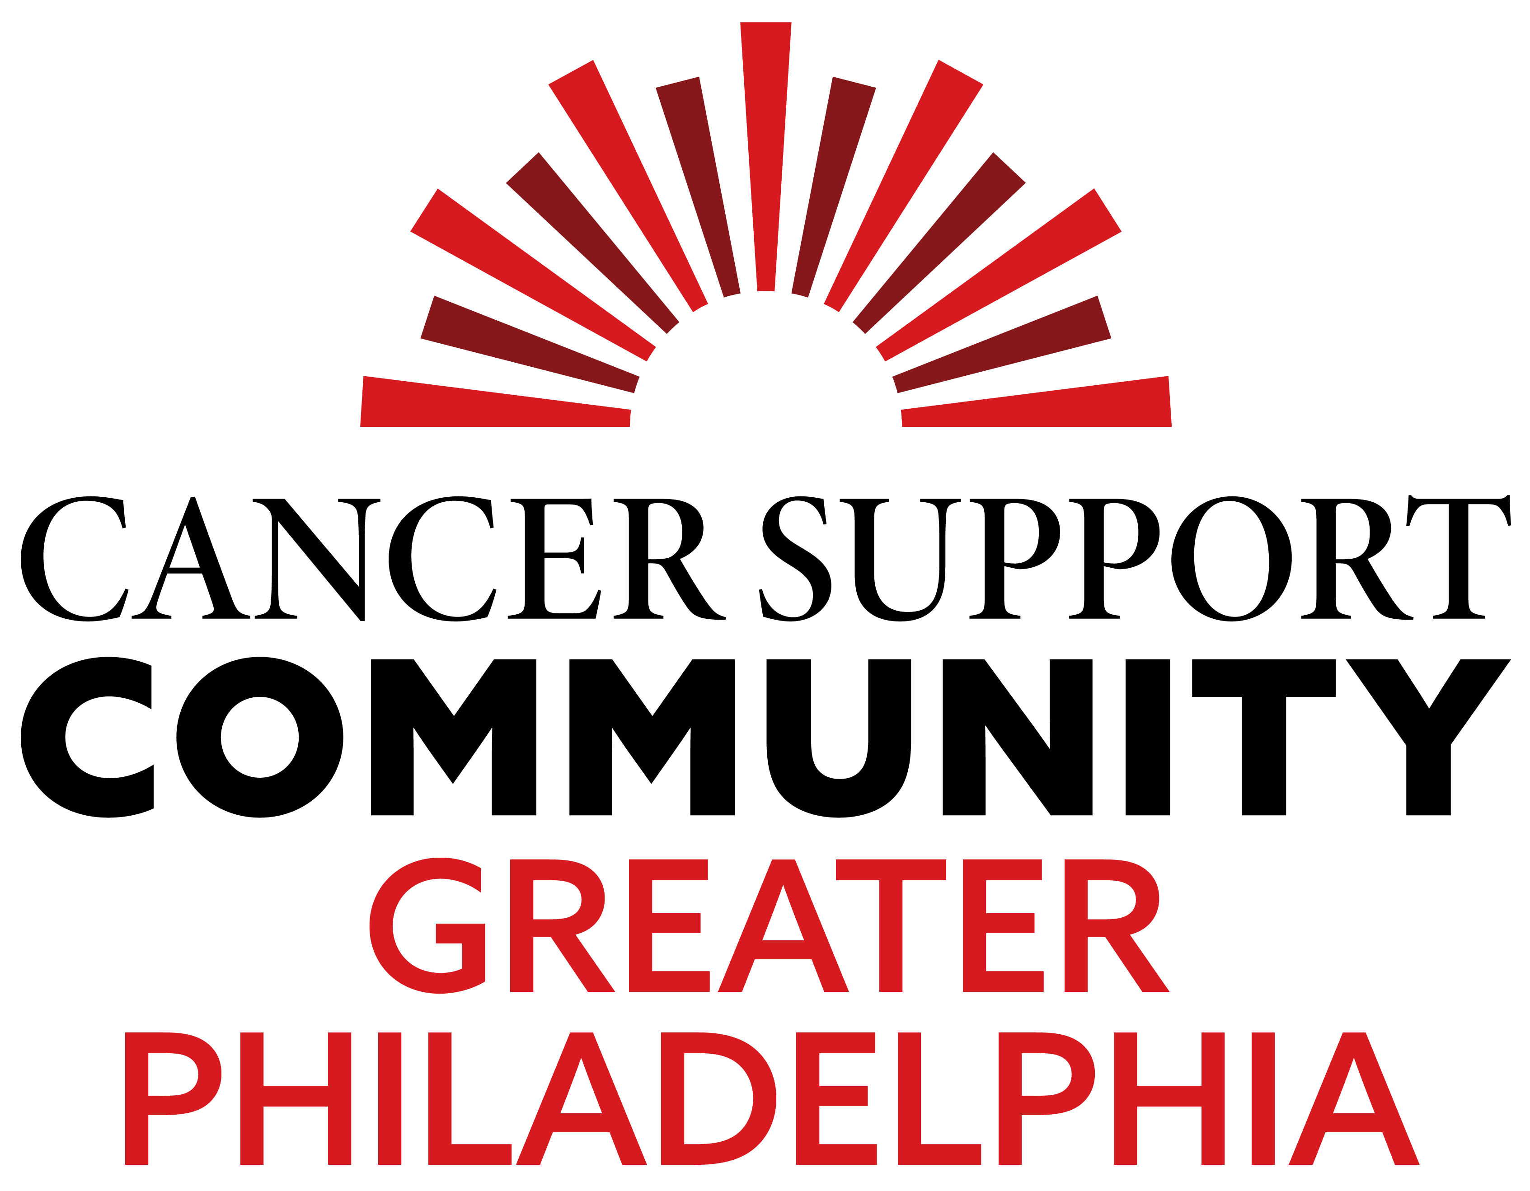 |  |  | October 13, 2025, Golf Outing  North Hills Country Club  Proceeds benefit Cancer Support Community Greater Philadelphia
Title Sponsor: $10,000  Our exclusive “Presented By” Title Sponsorship. You receive full recognition as the title sponsor, including signage, all press releases, invitations, sponsor sign, website, and at the Awards Ceremony. Complimentary golf for two foursomes, lunch, and dinner are also included.  Flag Sponsor: $5,000  Flag at each hole with company logo. Listing on Tournament invitations and day of event book Complimentary golf, lunch and dinner for one foursome is also included.  Dinner Sponsor: $3,500  No longer available -Exclusive sponsorship for event dinner. Signage with your company logo on all tables. Listing on Tournament invitations, sponsor sign, and at the Awards Ceremony. Complimentary golf for one foursome, lunch, and dinner are also included, as are two additional tickets to the dinner.  Cocktail Reception Sponsor: $3,000  Sponsor(s) of the cocktail reception. Listing on Tournament invitations, sponsor sign, website, and Awards Ceremony. Complimentary golf for one foursome, lunch, and dinner included.  Lunch Sponsor: $2,500  Exclusive sponsorship for lunch event. Signage with your company logo on all tables. Listing on tournament invitations, sponsor sign, website, and at the Awards Ceremony. Complimentary golf, lunch, and dinner for one foursome, as are two additional tickets to dinner.  Dessert Sponsor: $2,500  Sponsor(s) of the event dessert. Signage with your company logo on all tables. Listing on Tournament invitations, sponsor sign, website, and at the Awards Ceremony. Complimentary golf for one foursome, lunch, and dinner are also included.  Driving Range Sponsor: $2,500  Sponsor(s) for the Driving Range. Listing on Tournament invitations, sponsor sign, and at the Awards Ceremony. Complimentary golf, lunch and dinner for one foursome is also included.  Note: All sponsor commitments must be received by September 16th to be recognized on signage, and on the pre-event press release. |  |  |  | Ball Drop Sponsor: $2,000  No longer available Your company will be highlighted at the Ball Drop Contest each contest as well as listed on tournament invitations, sponsor sign, website. Complimentary golf for one foursome, lunch, and dinner are also included, as are two additional tickets to the dinner.  Golf Cart Sponsor: $2,000  Sponsor(s) of golf carts. Signage in carts, and listing on tournament invitations, sponsor sign, website, and at the Awards Ceremony. Complimentary golf, lunch, and dinner for two golfers are also included.  Mulligan Sponsor: $1,500  Sponsor(s) of the Mulligan cards. Your company’s logo will be printed on each card. Listing on Tournament invitations, sponsor sign, website, and at the Awards Ceremony. Complimentary golf, lunch, and dinner for two golfers are also included.  Snack Station Sponsor: $1,500  Sponsor(s) on a course snack station. Signage at the station with your company logo. Listing on Tournament invitations, sponsor sign, website and at the Awards Ceremony. Complimentary golf, lunch, and dinner for one golfer are also included.  Putting Contest Sponsor: $1,000  Sponsor(s) Sponsor sign at contest, website and at the Awards Ceremony recognition. Two dinner tickets. (no golfer sponsorship level)  Community Leader Sponsor: $750  Sponsor(s) Sponsor sign at tee, website and at the Awards Ceremony recognition. Two dinner tickets. (no golfer sponsorship level)  CSCGP Champion Sponsor: $500  Sponsor(s) Sponsor sign at tee, website and at the Awards Ceremony recognition. One dinner ticket. (no golfer sponsorship level)  Legacy IMO/ IHO – Sponsor: $250  Sponsor(s) Sponsor sign at tee in memory/ in honor of loved one/ friend/ colleague. (no golfer sponsorship level)  Individual Golfer: $325  Golf Foursome: $1,300
 | 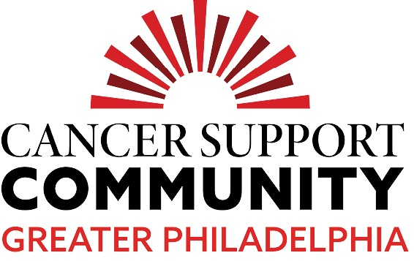 | Cancer Support Community Greater Philadelphia  North Hills Country Club Golf Tournament

Contact Name______________________________________________________________________________________
Company Name____________________________________________________________________________________
(As you wish it to appear in print)
Address___________________________________________________________________________________________
Telephone (Work)________________________________ (Home)___________________________________________
E-mail Address_____________________________________________________________________________________
Please Check Appropriate Level of Donation:
____ Title Sponsor $10,000 | ____ Snack Station Sponsor $1,500
____ Flag Sponsor $5,000 | _____ Putting Contest Sponsor $1,000
No longer available- Dinner $3,500 | _____ Community Leader Sponsor $750
____ Cocktail Reception Sponsor $3,000 | _____ CSCGP Champion Sponsor $500
_____Lunch Sponsor $2,500 | _____ Legacy Sponsor $250
____ Dessert Sponsor $2,500 | _____ Individual Golfer(s) $325 x # of golfers
____ Driving Range Sponsor $2,500 | _____ Foursome $1,300
No longer available Ball Drop Sponsor $2,000 | _____ Dinner attendance only $150
____ Golf Cart Sponsor $2,000 | ______ I would like to donate in support for event but will not be attending/ golfing $________
____ Mulligan Sponsor $1,500

If my donation is being made in memory or/ in honor of please note name:________________________

____ Number of Individual Golfers Attending

Names of Golfer ________________________ Name of Golfer ___________________________

Names of Golfer ________________________ Name of Golfer _____________________________

Check: My check in the amount of $________accompanies this entry form. Written to Cancer Support Community Greater Philadelphia (CSCGP) 200 Kirk Road, Warminster, PA 18974

If prefer Credit Card: (please circle one) Visa MasterCard American Express Discover
Card Number_______________________________ Expiration Date________________ CVC
Name as it appears on card _____________________ Signature____________________
Or make payment online with credit card visit cancersupportphiladelphia.org and select our Event Tab - Golf
Either email or mail this registration form to Cindy@cancersupportphiladelphia.org. Cancer Support Community Greater Philadelphia, 200 Kirk Road, Warminster, PA 18974 You can reach Cindy at 215-441-3290
Company logos should be sent to by Sept. 16th to Cindy@cancersupportphiladelphia.org

